DESFORD NEIGHBOURHOOD DEVELOPMENT PLAN

SITE SELECTION FRAMEWORK

October 2019

The sustainable site assessment (SSA) process

The attached SSA report, map and the NDP commentary set out the process undertaken and the reasons why only one residential development site has been granted an allocation in the NDP.

The SSA process has been completed on two occasions, the previous results from December 2018 have been comprehensively updated and the current twelve strategic housing and economic development sites (SHELAA sites) identified by HBBC have been analysed in the current process.

The Parish Council do not believe that either of the potentially massive “New Desford” planning applications are viable or sustainable for the parish.
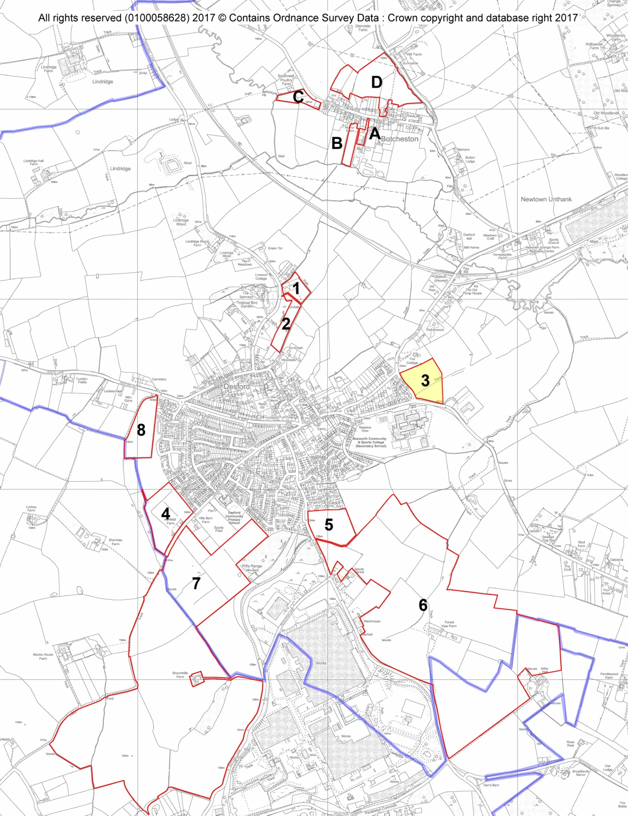

Introduction

  - The Neighbourhood Plan for Desford Parish Council has been prepared by the Desford Neighbourhood Plan Working Group on behalf of the Parish Council. One of the important objectives of the Neighbourhood Development Plan is to set out where new residential development should be built within the Parish, to meet the parish housing target set by Hinckley and Bosworth Borough Council (HBBC).

  - This report is an update of the first document containing the revised Strategic Housing and Economic Land Availability Assessment (SHELAA) sites publicised by HBBC between mid - December 2018 and April 2019.
  - A final housing target for Desford has been identified by HBBC based upon an agreed population and economic development increase in numbers and activity. The objectively assessed need (OAN) between 2016 and 2036 is for 163 additional dwellings, based on the proportion of the population of Desford as a proportion of the Borough as a whole. However, as explained fully in the NDP text, with dwellings completed, planning permissions already granted and a substantial site allocation the NDP aims to deliver 238 units by 2036.

  - This site selection framework sets out how the Desford Neighbourhood Plan Working Group (DNPWG), identified sustainable sites for the allocation of land for housing development. The recommendations made by the Working Group were informed by evidence collected and assessed by a Housing Focus Group (HFG), supported by an independent consultant.

  - The Neighbourhood Plan supports the provision of sustainable housing in the Parish and has embraced the desire to exceed the Borough-wide housing provision target by identifying potential housing sites within the Parish to meet these requirements within locations that are deliverable, developable and most acceptable to the local community.

Where did the site suggestions come from?

  - HBBC has prepared a SHELAA which identifies the potentially available sites put forward by landowners for residential development. This exercise was substantially updated in December 2018 and identified potential sites within Desford parish (including Botcheston). A scoring matrix based upon the methodology supported by the National Planning Policy Frameworks (NPPFs) of 2012, 2018 and 2019 was agreed by HFG members to reflect the unique characteristics of Desford parish.

  - A total of twelve sites were assessed for residential suitability through a robust Sustainable Site Assessment (SSA) process to arrive at a ranking of sites to determine which were to be presented to the community as being subject to allocation through the Neighbourhood Plan.

Site SelectionCriteria

  - The initial site assessments were undertaken by the Consultant from YourLocale to ensure a professional approach based upon past experience of similar assessments and to ensure a high level of objectivity and consistency in scoring. The assessment included a comprehensive desk top study and on line research followed by a visit to each of the sites. The initial results were then considered in detail by the HFG members, including the Consultant, to ensure that all local factors had been fully considered and were reflected in the reports. This led to some amendments being agreed by all members of the HFG and it was then possible to rank each site in order of overall sustainability. The policy position of HBBC in terms of their assessment of the developability of these SHELAA sites was a material consideration in these discussions of scoring.

The Criteria and the RAG Scoring System

  - The SHELAA methodology jointly agreed between the Local Planning Authorities (including HBBC) of Leicester and Leicestershire was used, coupled with the experience of the consultant in recommending past “made” neighbourhood plan site allocations that have been supported in an independent planning examination.

  - The HFG agreed twenty nine scoring criteria in a SSA scoring matrix that are relevant to the selection and allocation of sites for new dwellings, using evidence from the NPPFs of 2012, 2018 and 2019 (the core planning principles).
  - A scoring system, based on a Red, Amber or Green (RAG) score was applied to each criterion and listed for each identified site. Red was scored for a negative assessment; Amber was scored where mitigation might be required; Green was scored for a positive assessment. A different methodology for scoring to give varying weights to different criteria was considered by the HFG but rejected as it would be more complicated, less transparent to the community and could possibly be more subjective.

  - The following site assessment framework was used to compare each site.

Table 1 – Sustainable Site Assessment (SSA) framework for Desford

Issue | Green | Amber | Red
1. Site capacity. | Small capacity up to 15 dwellings alone or in conjunction with another  site | Medium capacity of between 16-49 dwellings | Large capacity of more than 50 dwellings
2. Current Use. | Vacant | Existing uses need to be relocated | Loss of important local asset
3. Adjoining Uses. | Site wholly within residential area or  village envelope | Site adjoining village envelope or  residential location | Extending village envelope outside  boundary
4. Topography. | Flat or gently sloping site | Undulating site or greater slope that can  be mitigated | Severe slope that cannot be mitigated
5. Greenfield or Previously Developed Land. | Previously developed land  (brownfield) | Mixture of brownfield & greenfield land | Greenfield land
6. Good Quality Agricultural Land (Natural England classification). | Land classified 4 or 5 (poor and very poor) | Land classified 3 (good to moderate) | Land classified 1 or 2 (Excellent and very good)
7. Site availability -Single ownership or multiple ownership. | Single ownership | Multiple ownership | Multiple ownership with one or more unwilling partners
8. Landscape Character Assessment and Visual Impact Assessment (LVIA). | No harm to quality | Less than substantial harm to quality | Substantial harm to quality
9. Important Trees, Woodlands & Hedgerows. | None affected | Mitigation measures required | Site would harm or require removal of Ancient tree or hedge (or TPO)
10. Relationship with existing pattern of built development. | Land visible from a small number of properties | Land visible from a range of sources mitigated through landscaping or planting | Prominent visibility  Difficult to improve
11. Local Wildlife considerations. | No impact on wildlife site | Small to medium impact but with  potential to mitigate | Statutorily protected species in place
12. Listed Building or important built assets and their setting. | No harm to existing building | Less than substantial harm | Substantial harm
13. Impact on the Conservation  Area or its setting. | No harm | Less than substantial harm | Substantial harm
14. Safe pedestrian access to and from the site. | Existing footpath | No footpath but can be created | No potential for footpath
- Safe vehicular traffic to and from the site. | Appropriate access can be easily provided | Appropriate access can only be provided with significant improvement | Appropriate access cannot be provided
- Impact on existing vehicular traffic. | Impact on village centre minimal | Medium scale impact on village centre | Major impact on village centre
- Safe access to public transport (specifically a bus stop with current service). | A distance of 250m or less | A distance of 251-500m | A distance of greater than 501m
18. Distance to designated village centre (the cross). | A distance of 250m or less | A distance of 251 – 500m | A distance of greater than 501m
19. Distance to GP/Health Centre. | A distance of 250m or less | A distance of 251-500m | A distance of greater than 501m
20. Distance to Primary School. | A distance of 250m or less | A distance of 251-500m | A distance of greater than 501m
21. Current existing informal/formal recreational  opportunities on site. | No recreational uses on site | Informal recreational uses on site | Formal recreational uses on site
22. Ancient monuments or archaeological remains. | No harm to an ancient monument or  remains site | Less than substantial harm to an ancient  monument or remains site | Substantial harm to an ancient  monument or remains
23. Any existing public rights of ways/bridle paths. | No impact on public right of way | Detriment to public right of way | Re-routing required or would cause significant harm
24. Gas and/or oil pipelines & electricity transmission network  (Not water/sewage). | Site unaffected | Re-siting may be necessary | Re-siting may not be possible
25. Any noise issues. | No noise issues | Mitigation may be necessary | Noise issues will be an ongoing concern
26. Any contamination issues | No contamination issues | Minor mitigation required | Major mitigation required
27. Any known flooding issues. | Site in flood zone 1 or 2 or no flooding for more than 25 years | Site in flood zone 3a or flooded once in last 25 years | Site in flood zone 3b (functional flood plain) or flooded more than once in last  25 years
28. Any drainage issues. | No drainage issues identified | Need for mitigation | Drainage concerns.
29. Distance to nearest employment site. | A distance of less than 250m. | A distance of 251-500m. | A distance of more than 501m.

- The assessment outcome

  - The assessments were considered at a number of meetings of the HFG to ensure that adequate local knowledge was central to the process. This led to a re-assessment of some sites by the YourLocale Consultant with amendments subsequently agreed with the HFG members to ensure an objective and transparent approach prior to the assessments being agreed.

  - The twelve previously identified sites (without an indication of the assessment outcome) have been shared at an Open Event in the Village Hall where residents of the parish were asked to indicate which sites they preferred for development.

  - The assessments were amended to reflect this input and then circulated as drafts to the relevant site sponsor, usually the land owner or a professional agent working on their behalf. All parties have been invited to discuss the reports in a “face to face” meeting with HFG members and the reports have been analysed line by line and further amendments made.

  - The responses from land owners were then further considered by HFG members and the consultant to ensure that all factors have been fairly considered.

  - The outcome of the assessment is as recorded on the following table. The RAG Rating is obtained by deducting the “Red” scores from the “Green” scores. Amber remains neutral.

  - The final approved site is highlighted in the table below in bold Green type:

Table 2 – THE SSA outcomes

SSA reference and Site Location | SHELAA reference | RAG SCORE
Botcheston A – Rear of Snowdene – Main Street | AS 196 | Green five
Botcheston B – Rear of 38 Main Street | LPR 66 | Red negative five
Botcheston C –Hind Quarters Main Street | AS195 | Green two
Botcheston D – New Botcheston North of Main Street | AS194 | Red negative eight
Desford 1 – Sewage treatment plant Lindridge Lane | AS 206 | Red negative two
Desford 2 – Lyndale boarding cattery, Lindridge Lane | AS 610 | Red negative seven
Desford 3 - Barns Way Extension | LPR37/45 (AS203) | Green eleven
Desford 4 – Ashfield Farm and Kirkby Lane Extension | AS 210& AS211 | Red negative five
Desford 5 – Peckleton Lane | AS 201 | Green four
Desford 6 - New Desford South Expansion | AS 200 | Red negative thirteen
Desford 7 – Neovia New Desford Expansion | LPR 24 | Red negative thirteen
Desford 8 – South of Hunts Lane | N/A | Green three

  - The NDP has allocated the highest scoring green site, the Barns Way extension site. This allocation, along with the other consents and an estimation of windfall units, exceed the HBBC target and the Barns Way site is known to be developable and deliverable, with planning permission granted by HBBC.

Desford Neighbourhood Plan Working Group. October 2019.

